**HACKATHON PROJECT**

TOPIC – IDENTIFY COURSES (COURSERA)

**SOFTWARE REQUIREMENTS SPECIFICATIONS**

|  |  |  |  |
| --- | --- | --- | --- |
|  | Prepared By | Reviewed By | Approved By |
| Name | KOLOINC | P., Devathilagai |  |
| Role | Interns | Batch Trainer |  |

**Table of Contents**

Table of Contents…………………………………………………………..….......II

1. Introduction…………………………………………………………………..…1

1.1 Intended Audience……………………………………………….......1

1.2 Project Scope…………………………...……………………………1

2. Overall Description…………………………………………….……………….1

2.1 Operating Environment……………………...……………………....1

3. Requirements……………………………………………………………...…….1

3.1Login………………………………………………………………….2

3.1.1Description………………………………………………....2

3.1.2 Functional Requirements……..…………………………...2

**1. INTRODUCTION**

The purpose of this project is to develop an automated web-based solution that identifies and extracts relevant information about educational courses from legitimate online learning platforms such as Coursera.org. The system focuses on three core functionalities: searching for beginner-level web development courses in English, analyzing language learning offerings, and interacting with enterprise-level forms to capture validation errors. This automation aims to streamline the process of course discovery, data extraction, and form validation testing, which are essential for educational research, user experience testing, and enterprise readiness assessments.

**1.1 Intended Audience**

* Business Unit (BU) SME
* Academy coach
* Technical Trainer

**1.2 Project Scope**

This document defines, at a functional level, the business activities encompassed by the system and the rules that govern them. It also outlines key high-level and low-level technical requirements essential for the successful implementation of the system.

The scope of this detailed analysis phase draws heavily on the proposed automation framework, business rules, and technical architecture. It aims to provide a comprehensive understanding of the system’s behavior, structure, and interactions.

Specifically, this document includes:

* **Classification of Requirements by Functional Areas**  
  Requirements is grouped based on core functionalities such as course discovery, language learning analysis, and enterprise form validation. Each functional area is described with its specific objectives and expected outcomes.
* **Process Descriptions**  
  Each process within the system is detailed with its respective inputs, outputs, and data transformation rules. This includes:
  + Searching and filtering web development courses based on beginner level and English language.
  + Extracting course metadata such as name, duration, and rating.
  + Analyzing language learning offers by identifying available languages and categorizing them by proficiency levels.
  + Navigating enterprise-level pages, interacting with form elements, and capturing validation errors.

The system will leverage browser automation techniques to handle dynamic content, multiple windows, dropdown lists, form inputs, and scrolling actions. These capabilities ensure robust interaction with modern web interfaces and accurate data extraction

**2. OVERALL DESCRIPTION**

This section provides a high-level overview of the system, including its environment, user interactions, and general constraints. It outlines the context in which the system will operate and the foundational elements that support its functionality.

**2.1 Operating Environment**

The system will be developed and executed within the following technical environment:

* **Operating System**:  
  The automation framework will run on the **Windows operating system**, compatible with Windows 10 and above.
* **Application Type**:  
  The target application is a **web-based platform**, specifically educational websites such as Coursera.org. The automation will interact with dynamic web elements, forms, dropdowns, and navigation menus within a browser environment.
* **Programming Language**:  
  The automation scripts will be written in **Java**, leveraging object-oriented principles and modular design patterns.
* **Automation Tools & Frameworks**:
  + **Selenium WebDriver**: For browser automation and interaction with web elements.
  + **TestNG**: For test execution management, assertions, and reporting.
  + **Apache POI**: For reading and writing data to Excel files, useful for data-driven testing.
  + **Page Object Model (POM)**: To promote maintainability and reusability by separating page-specific logic.
  + **Behavior-Driven Development (BDD)**: To define test scenarios in a human-readable format.
  + **Cucumber**: For implementing BDD using Gherkin syntax and integrating with Selenium and TestNG.
* **Browser Support**:  
  The system will support modern browsers such as **Google Chrome** and **Microsoft Edge**, with appropriate WebDriver configurations.
* **Network Requirements**:  
  A stable internet connection is required to access and interact with the web application in real time.

**3. REQUIREMENTS**

This part of the requirements document serves to present the "Coursera for Web Development Courses" functionality of the application. It also includes the extraction of all levels in the “Language Learning” section, along with additional workflows related to enterprise forms, course details, and footer interactions.

**3.1.1 Functional Requirements**

**3.1.1.1 Req0001 – Web Development Course Search**

* **Req0001a** – The user enters the text “Web Development” in the search box and selects “Web Development” from the auto-suggestion list.
* **Req0001b** – The user clicks the “English” option under the ‘Language’ filter.
* **Req0001c** – The user clicks the “Beginner” option under the ‘Level’ filter.
* **Req0001d** – Extract and display the first courses results with:
  + Course Name
  + Total Learning Hours
  + Rating

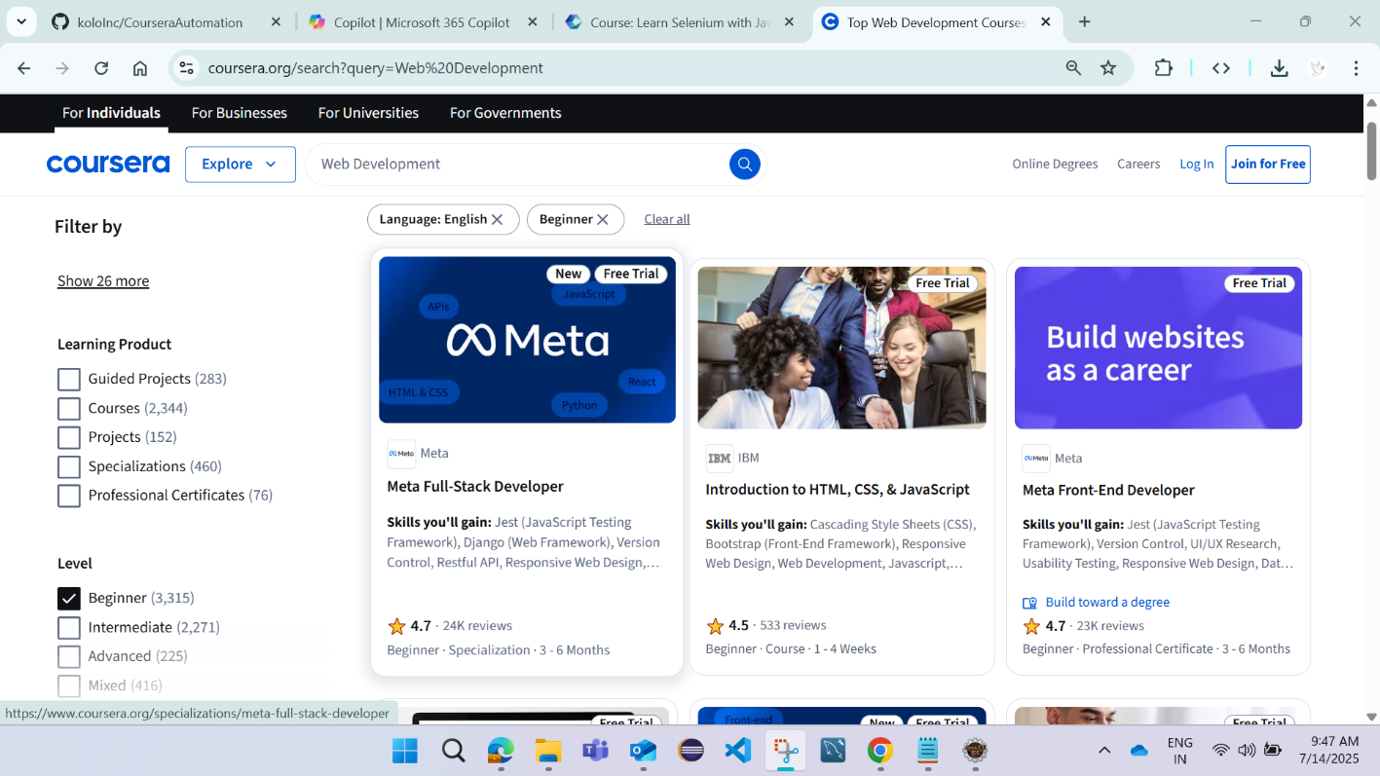

**3.1.1.2 Req0002 – Language Learning Analys**

* **Req0002a** – The user enters the text “Web Development” in the search box and selects “Web Development” from the auto-suggestion list.
* **Req0002b** – The user clicks on ‘Show more’ under the “Language ” section.
* **Req0002c** – Extract and display all available languages and levels with their respective course counts.

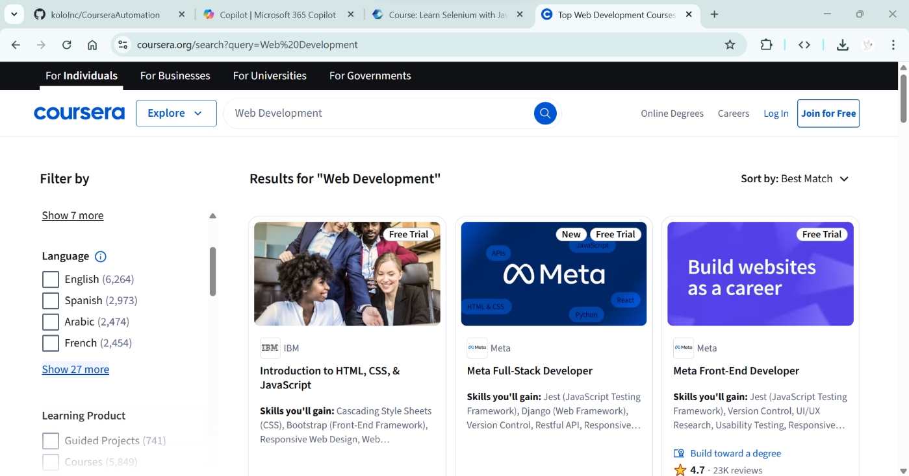

**3.1.1.3 Req0003 – For Business Form Validation**

* **Req0003a** – Click the “For Business” button to navigate to the business page.
* **Req0003b** – Scroll down and fill in the necessary details.
* **Req0003c** – Enter wrong Email and Mobile Number format.
* **Req0003d** – Capture the displayed error message.

**3.1.1.4 Req0004 – Individual Partners in India**

* **Req0004a** – Click on the “Individual” menu option.
* **Req0004b** – Navigate to the “Partners” section.
* **Req0004c** – Filter or select the Country from the available options.
* **Req0004d** – Extract and display the following details for each partner:
  + Logo displayed
  + Name
  + Website Link

**3.1.1.5 Req0005 – Online Degree Program Filtering**

* **Req0005a** – Navigate to the “Online Degree” section.
* **Req0005b** – Apply filters based on:
  + Program Level (e.g., Bachelor’s, Master’s)
  + Multiple selection options
* **Req0005c** – Extract and display the total number of programs listed after filtering.

**3.1.1.6 Req0006 – Business Plan Purchase Summary**

* **Req0006a** – Navigate to the “For Business” section.
* **Req0006b** – Click on “For Teams”.
* **Req0006c** – Click on “Get Started”.
* **Req0006d** – Enter the number of users.
* **Req0006e** – Choose a billing cycle (Annually or Quarterly).
* **Req0006f** – Click “Continue” and extract the **Purchase Summary Table**.

**3.1.1.7 Req0007 – Course Details from Search Result**

* **Req0007a** – After completing the Web Development course search (Req0001), click on the first course result.
* **Req0007b** – Extract and display detailed course information including:
  + Mentor Name
  + Rating
  + Level
  + Duration
  + Course Description (if available)

**3.1.1.8 Req0008 – Government Contact Form Submission**

* **Req0008a** – Navigate to the “For Government” section.
* **Req0008b** – Click on “Contact Sales” (top-right corner).
* **Req0008c** – Fill in the form with the following details:
  + First Name, Last Name
  + Work Email
  + Mobile Number
  + Organization Type (select “Non-Government/Government”)
  + Job Title (random value)
  + Organization Name (random value)
  + Organization Size (select the third option)
  + Country (random value)
* **Req0008d** – Click on “Request Info” and capture the confirmation or success message displayed on the next page.

**3.1.1.9 Req0009 – Footer Skills List Extraction**

* **Req0009a** – Scroll to the bottom of the Coursera homepage (footer section).
* **Req0009b** – Extract and display all list items under the following categories:
  + Technical Skills
  + Analytical Skills
  + Business Skills
  + Career Resources
  + Coursera
  + Community
  + More

**3.1.1.10 Req0010 – App Store Link Validation via Screenshots**

* **Req0010a** – Scroll to the footer section of the homepage.
* **Req0010b** – Click on the **Apple App Store** logo.
* **Req0010c** – Take a screenshot of the page that opens and save it to a designated folder.
* **Req0010d** – Return to the Coursera homepage.
* **Req0010e** – Click on the **Google Play Store** logo.
* **Req0010f** – Take a screenshot of the page that opens and save it to the resources folder.
* **Req0010g** – Validate that both links are working correctly by confirming that the screenshots were successfully captured.

**3.1.1.11 Req0011 – Social Media Link Extraction**

* **Req0011a** – Scroll to the footer section of the homepage.
* **Req0011b** – Click on each social media icon (e.g., Facebook, Twitter, LinkedIn, Instagram) one by one.
* **Req0011c** – Open each link in a new browser tab or window.
* **Req0011d** – Extract and print the **title** and **URL** of each opened page.
* **Req0011e** – Save the extracted data into an Excel file.

**3.1.1.12 Req0012 – Career Opportunities Extraction**

* **Req0012a** – Scroll to the footer and click on the **Careers** link under the Coursera section.
* **Req0012b** – Click on **Explore Opportunities**.
* **Req0012c** – Filter or select **India** as the country.
* **Req0012d** – Extract and save the list of job opportunities displayed into an Excel file, including:
  + Job Title
  + Location
  + Department (if available)

